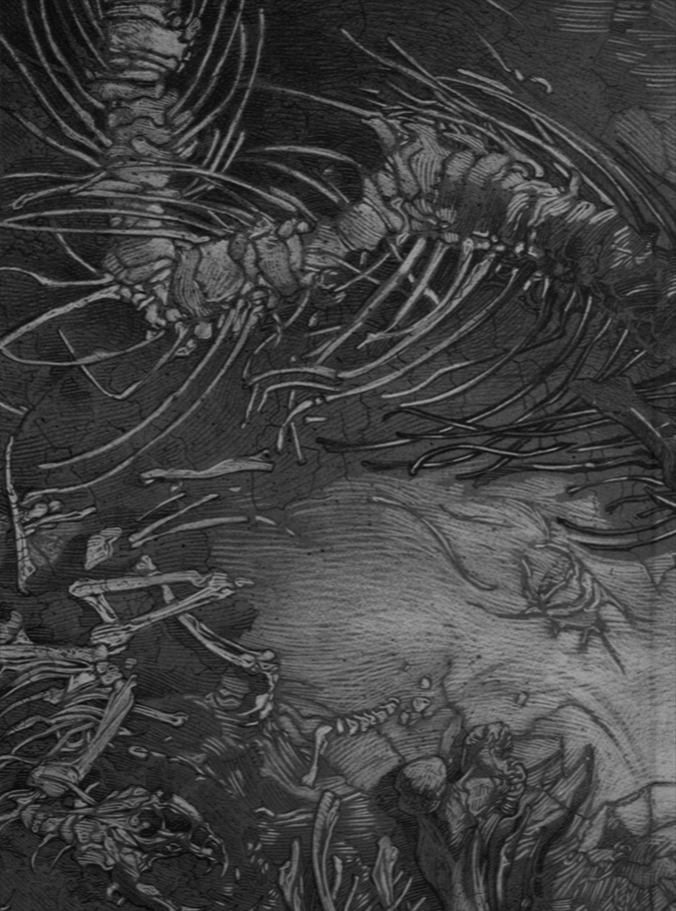
Name
RasseDisziplinBeschreibung

Kreis
Status

Erholung
Karma

SchadenWunden

LP
LP akt.

AttributWertStufeWürfelGesStäZähWillWahCha

körp. WSK
körp.
RüstWundemag. WSK
myst. RüstK.O.soz. WSK
INI

TalentRangAttrStufeWürfelKarmaÜAKreisAkt
ion Bemerkung
St | Würfel
3 | 4
4 | 6
5 | 8
6 | 10
7 | 12
8 | 6,6
9 | 8,6
10 | 10,6
11 | 10,8
12 | 10,10
13 | 12,10
14 | 20,4
15 | 20,6
16 | 20,8
17 | 20,10
18 | 20,12
19 | 20,6,6
20 | 20,8,6
21 | 20,10,6
22 | 20,10,8
23 | 20,10,10
24 | 20,12,10
25 | 20,10,8,4
26 | 20,10,8,6
27 | 20,10,8,8
28 | 20,10,10,8
29 | 20,12,10,8
30 | 20,10,8,6,6
31 | 20,10,8,8,6
32 | 20,10,8,8,8
33 | 20,10,10,8,8
34 | 20,3·10,8
35 | 20,12,2·10,8
36 | 2·20,10,8,4
37 | 2·20,10,8,6
38 | 2·20,10,8,8
39 | 2·20,2·10,8
40 | 2·20,12,10,8
40 | 2·20,12,10,8
41 | 2·20,10,8,2·6
42 | 2·20,10,2·8,6
43 | 2·20,2·10,8,6
44 | 2·20,2·10,2·8
45 | 2·20,3·10,8
46 | 2·20,12,2·10,8
47 | 2·20,2·10,2·8,4
48 | 2·20,2·10,2·8,6
49 | 2·20,2·10,3·8
50 | 2·20,3·10,2·8
51 | 2·20,12,2·10,2·8
52 | 2·20,2·10,2·8,2·6
53 | 2·20,2·10,3·8,6
54 | 2·20,3·10,2·8,6
55 | 2·20,3·10,3·8
56 | 2·20,4·10,2·8
57 | 2·20,12,3·10,2·8
58 | 3·20,2·10,2·8,4
59 | 3·20,2·10,2·8,6
60 | 3·20,2·10,3·8

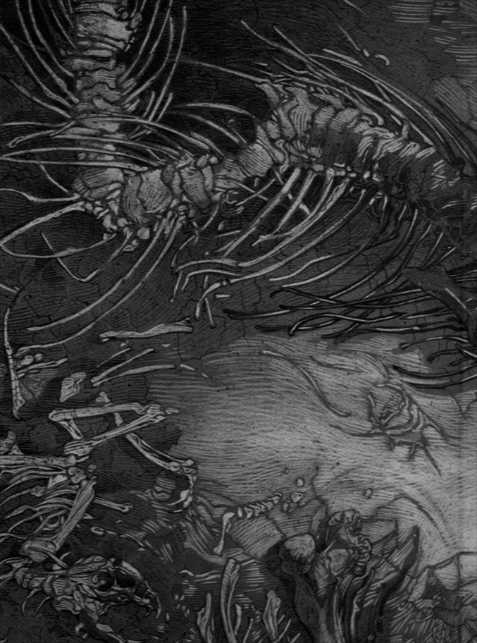
Vermögen
KM
SM
GM

Fertigkeit | Rang | Attr.

Fertigkeit | Rang | Attr.

Fertigkeit | Rang | Attr.

magischer Gegenstand | Rang | mWsk | SP

magische Gegenstände | Rang | mWsk | SP | Bemerkungen

Waffe | Stufe

Rüstung | Körp. | Myst. | - Ini

St | Würfel
3 | 4
4 | 6
5 | 8
6 | 10
7 | 12
8 | 6, 6
9 | 8, 6
10 | 10, 6
11 | 10, 8
12 | 10, 10
13 | 12, 10
14 | 20, 4
15 | 20, 6
16 | 20, 8
17 | 20, 10
18 | 20, 12
19 | 20, 6, 6
20 | 20, 8, 6
21 | 20, 10, 6
22 | 20, 10, 8
23 | 20, 10, 10
24 | 20, 12, 10
25 | 20, 10, 8, 4
26 | 20, 10, 8, 6
27 | 20, 10, 8, 8
28 | 20, 10, 10, 8
29 | 20, 12, 10, 8
30 | 20, 10, 8, 6, 6
31 | 20, 10, 8, 8, 6
32 | 20, 10, 8, 8, 8
33 | 20, 10, 10, 8, 8
34 | 20, 3·10, 8
35 | 20, 12, 2·10, 8
36 | 2·20, 10, 8, 4
37 | 2·20, 10, 8, 6
38 | 2·20, 10, 8, 8
39 | 2·20, 2·10, 8
40 | 2·20, 12, 10, 8
40 | 2·20, 12, 10, 8
41 | 2·20, 10, 8, 2·6
42 | 2·20, 10, 2·8, 6
43 | 2·20, 2·10, 8, 6
44 | 2·20, 2·10, 2·8
45 | 2·20, 3·10, 8
46 | 2·20, 12, 2·10, 8
47 | 2·20, 2·10, 2·8, 4
48 | 2·20, 2·10, 2·8, 6
49 | 2·20, 2·10, 3·8
50 | 2·20, 3·10, 2·8
51 | 2·20, 12, 2·10, 2·8
52 | 2·20, 2·10, 2·8, 2·6
53 | 2·20, 2·10, 3·8, 6
54 | 2·20, 3·10, 2·8, 6
55 | 2·20, 3·10, 3·8
56 | 2·20, 4·10, 2·8
57 | 2·20, 12, 3·10, 2·8
58 | 3·20, 2·10, 2·8, 4
59 | 3·20, 2·10, 2·8, 6
60 | 3·20, 2·10, 3·8

